14
TH
CONFERENCE OF THE
European Council of
Enterostomal Therapists
www.ecet2019.org
ECET 2019 · 23-26 June 2019 · Rome · Italy
Abstract submission deadline
1
February
2019
Call for abstracts
Welcome to ECET 2019

Invitation
It is a great pleasure to announce the 2019 Biennial Meeting of the European Council of Enterostomal Therapy (ECET).
Date and place 23-26 June 2019 in Rome, Italy
Conference theme Research meets Practice – Practice meets Research

Connecting people through knowledge, research and
experience in Ostomy, Wounds and Continence Care
The conference is for European Nurses with academic nature and good clinical experience for ostomy, incontinence and wound care
Why attend? | The ECET conference offers high level scientific presentations, networking activities and it provides an excellent opportunity to exchange knowledge and experiences with international colleagues.
Participate and... | › Become updated and educated on the
most recent knowledge and research within enterostomal therapy
› Get the opportunity to experience and meet with peer researchers and clinicians.
› Get the chance to attend a variety of high level key sessions, free paper sessions, hands-on workshops
› Meet your suppliers and exchange experiences with their products.
We look forward to welcoming you in Rome!

Kind regards from the Executive Board of ECET
Gabriele Kroboth, President
Werner Droste, Vice-President
Renata Batas, PR Officer
Danila Maculotti, Treasurer

Important dates

1 February 2019
Abstract submission deadline

15 March 2019 Early registration deadline

Conference venue

Marriott Rome Park Hotel
Via Colonnello Tommaso Masala, 54 00148 Roma, Italy

How to get there
Rome International Airport is located only 10 minutes from Marriott Park Hotel. There is a daily shuttle service from the airport to the hotel. Alternatively, you can take a taxi - estimated price for the fare is € 30.

Conference languages
English and Italian. Most sessions will be simultaneously translated english/italian, italian/english.

Accommodation
A number of hotel rooms have been reserved for the conference participants. These rooms can be booked via the online registration at favourable prices.

Contact us

ECET 2019
Conference Secretariat C/O CAP Partner Nordre Fasanvej 113, 2.
DK-2000 Frederiksberg
Denmark

Phone: +45 70 20 03 05
Fax: +45 70 20 03 15
Email: info@cap-partner.eu

Main topics

Ostomy – Continence – Wounds

The main topics of the conference programme will be:

Ostomy care
Stoma site marking
Use of Convexity
Complication management
Hernia prevention
Stoma reversal
Kock Pouch revival Paediatric ostomy
Urostomy
Stoma surgery

Continence care
Urinary incontinence
Fecal incontinence
ISK
Guidelines

Wound care
Open abdomen
Fistula management Negative pressure therapy

Submit your abstract
Please submit your abstract within one of the categories of Ostomy, Continence or Wound Care at the conference website ecet2019.org, where you will also find the abstract submission guidelines. The deadline for submitting abstracts is 1 February 2019.

Programme Schedule
(Preliminary schedule - subject to change)

Sunday 23 June
15.00 - 16.30 Registration and coffee
16.30 - 18.00 Opening session
18.00 - 20.00 Welcome reception and official opening
of the exhibition

Monday 24 June
07.30 - Registration open
08.30 - 17.30 Scientific sessions
10.00 - 16.00 Exhibition hours

Tuesday 25 June
07.30 - Registration open
08.30 - 17.30 Scientific sessions
10.00 - 16.00 Exhibition hours
19.00 - 24.00 Conference dinner

Wednesday 26 June
08.00 - Registration open
08.30 - 15.30 Scientific sessions
10.00 - 14.00 Exhibition hours

Registration fees (incl VAT)
 | Until 15 March 2017 | From 16 March 2017
ECET Members* | 427,00 EUR | 549,00 EUR
Non members | 585,60 EUR | 707,60 EUR
Students | 122,00 EUR | 183,00 EUR
One day reg. | 292,80 EUR | 353,80 EUR
*) In order to get the reduced fee you must be a member of ECET before 31. December 2018
Included in the registration fee
Admission to the full conference programme, welcome reception on 23 June, programme & abstract book and lunch breaks. Please note that coffee, tea etc. will be available for purchase onsite during the coffee breaks.

Invitation letter
Individuals requiring an official letter of invitation in order to obtain a visa are kindly asked to contact the conference secretariat at info@cap-partner.eu.
Please note that official letters of invitation can only be given to individuals who have registered and paid the registration fee for the conference. All requests will be considered individually.

Payment terms
By bank transfer or credit card through the online registration system. Payment by bank transfer is due immediately from receiving the invoice.

Cancellation terms
Cancellation of registration and accommodation must be notified in writing to CAP Partner at info@cap-partner.eu.
Cancellations postmarked before 15 April 2019 will be refunded deducting administration costs of 50 EUR.
15 April 2019, accommodation and registration fees are non-refundable.

If, for reasons beyond the control of the organisers, the conference is cancelled, the registration fee will be refunded after deduction of expenses incurred by the conference.
For more information please see the conference website www.ecet2019.org
About Rome
Rome is one of the most-visited cities in the world, 3rd most visited in the European Union, and the most popular tourist
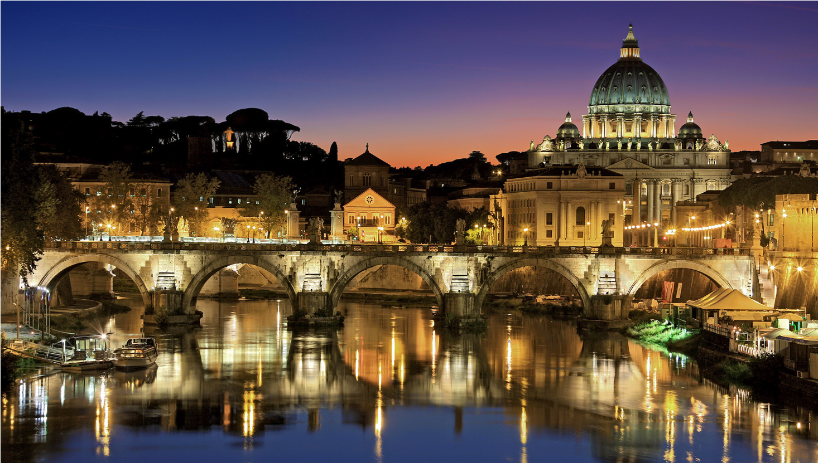
attraction in Italy.
The historic centre of Rome is listed by UNESCO as a World Heritage Site. Monuments and museums such as the Vatican Museums and the Colosseum are amongst the world’s 50 most visited tourist destinations.
After the intense days at the ECET 2019 conference you can take the opportunity to get further inspired by a visit to the city centre. Indulge yourself with the calm walk through the magnificent medieval streets, enjoy the scenery of the thousand years old monuments, feel the taste of Italian cuisine in one of the hundreds of unique restaurants.
Rome’s hot, dry summer days, with high temperatures often above 75 °F (24 °C), are frequently cooled in the afternoons by the ponentino, a west wind that rises from the Tyrrhenian Sea. The city receives roughly 30 inches (750 mm) of precipitation annually; spring and autumn are the rainiest seasons.

Gold sponsors
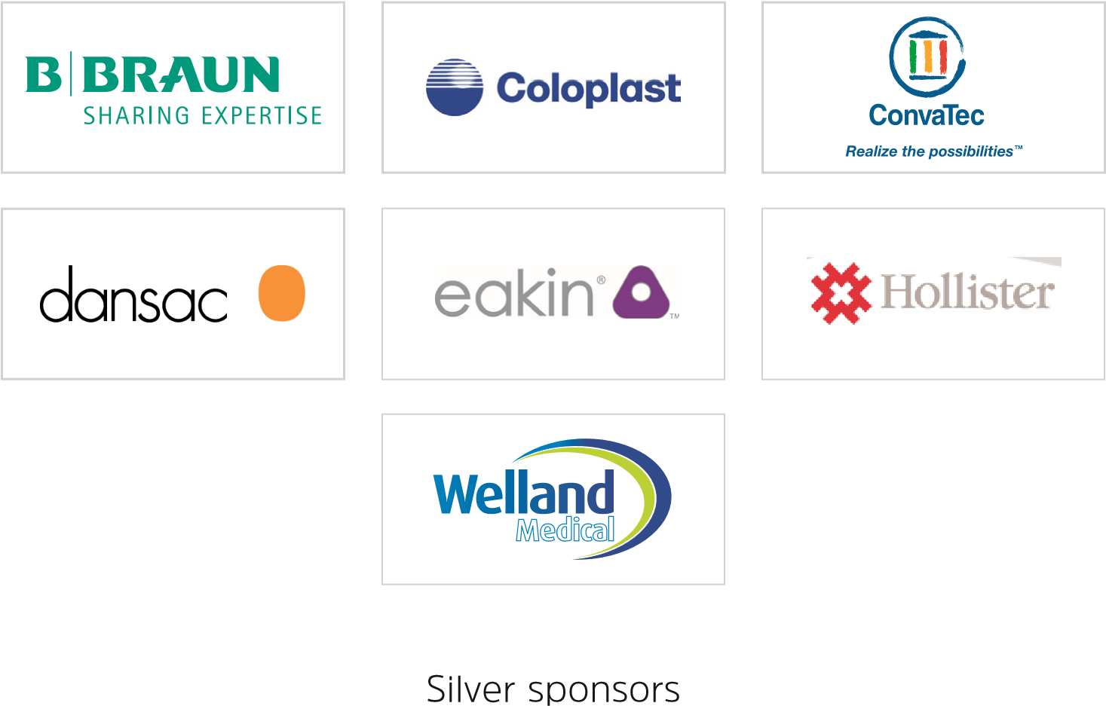
Bronze sponsor
Conference website

www.ecet2019.org

